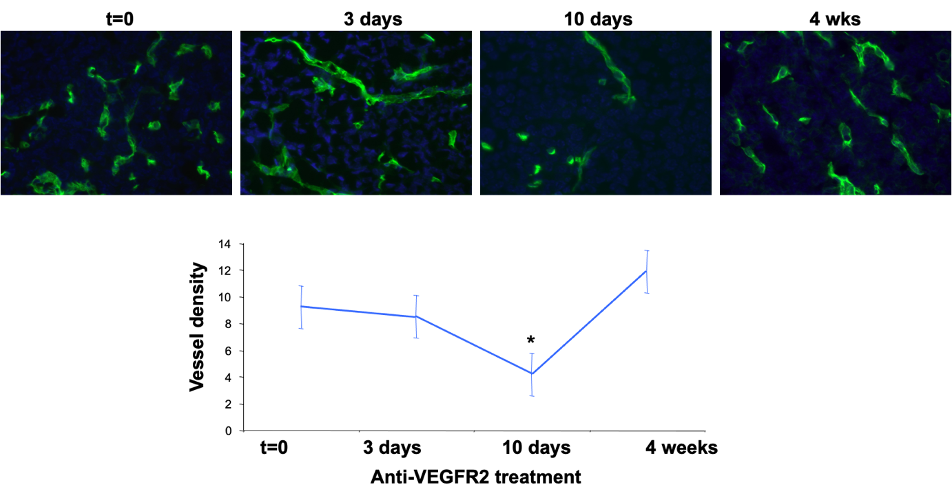
Exercise (Lecture VI)

Anti-angiogenic therapy

The figure shows angiogenesis in tumors of Rip1-Tag2 transgenic mice treated with a VEGFR2 inhibitor. Address the following questions:

1) What is a Rip1-Tag2 transgenic mouse? Why is this model useful in angiogenesis and anti-angiogenesis research?
2) Why is VEGF-VEGFR2 signaling important for tumor angiogenesis?
3) Describe the results shown in the figure above. Why does vessel density decrease at 10 days post-treatment to subsequently increase? What are the potential mechanisms involved?
4) How would you therapeutically address tumor revascularization at 4 weeks?

